**F.3 Mathematics Selection Test 2012-2013**

Name: ( ) Time Allowed: 35 minutes

Class: Full mark: 50

Part 1- (20 marks)

1. Let there be *n* teams in a tournament, a match requires 3 teams. Assume one match is held every day; find the maximum value of *n* in order to finish all matches in a year.

Answer: (2 marks)

1. If q2is divisible by 99, find *n* where *n*=10*x*+*y*

Answer: (3 marks)

1. If $x+y+z=1$ and $x^{2}+y^{2}+z^{2}=2$, find $x^{3}+y^{3}+z^{3}$

Answer: (5 marks)

1. Find the area of the shaded part in the diagram in terms of pi if the sides of the square have length 1cm

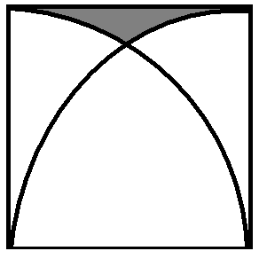

Answer: (4 mark)

1. Find the value of $\frac{1}{4}+\frac{1}{4^{2}}+\frac{1}{4^{3}}+…$

Answer: (3 marks)

1. Find the value of $\sqrt{2+\sqrt{2+\sqrt{2+…}}}$

Answer: (3 mark)

Part 2- (30 marks) (PLEASE SHOW YOUR STEPS CLEARLY)

1. Prove that $x^{2}y+y^{2}z+z^{2}x≥xyz$, given that x, y, z are non-negative real numbers.

(Hint: arithmetic mean $≥$ geometric mean) (10 marks)

2. Find the probability of getting a sum of 9 if we roll three fair die, where two of them are four-faced and the other one is five faced. (10 marks)

3. Find six prime numbers with have the last four digits 4321. (10 marks)

End of paper